FCA UK Resilience Compliance for Log360
Automate FCA UK Resilience compliance and fortify cybersecurity resilience for financial institutions.
Region: UK | Type: Data Privacy, Financial Services, Incident Management, Operational Resilience | Category: Compliance | Pricing: Free

Overview
The FCA UK Resilience compliance extension in Log360 helps organizations meet the FCA Operational Resilience Rules (Policy Statement PS21/3, UK), UK Financial Conduct Authority rules requiring regulated firms to identify Important Business Services and demonstrate resilience within defined impact tolerances by providing centralized log management, continuous security monitoring, and operational event tracking. The platform supports FCA UK Resilience requirements for governance, access control, incident response, business continuity, third-party risk, network security, data protection, and operational monitoring.
For Governance and IBS Accountability, Log360 tracks AD policy changes, GPO configurations, user and group auditing, and computer asset changes to support IBS governance documentation. To address Access Control and Authentication, the platform captures Windows and Unix logon/failed logon events, AD logon activity, and MFA authentication records to enforce access security. The extension also supports Operational Monitoring and Event Management by providing capabilities that aggregates Windows system events, EventLog data, database audit logs, and detailed system event reports for operational visibility.

Key Features
- Incident Response and Management: Log360 provides threat detection from FireEye, Trend Micro, McAfee, Windows threat reports, and network attack logs for incident analysis.
- Business Continuity and Recovery Testing: Log360 monitors Backup and Disaster Recovery infrastructure, policies, job statuses, and Windows Backup and Restore events.
- Third-Party and Supply Chain Risk: Log360 audits cloud storage integration, third-party access reports, AWS IAM activity, and failed/unauthorized cloud activity.
- Network Security and Perimeter Controls: Log360 audits network device logon, account management, policy changes, attack reports, Windows firewall events, and network security configurations.
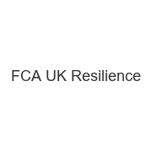
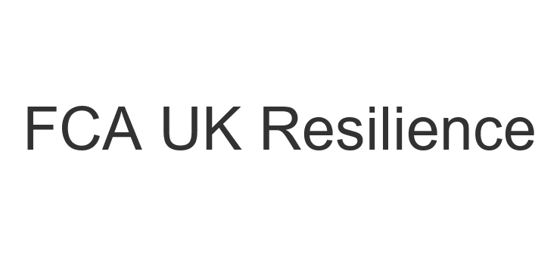
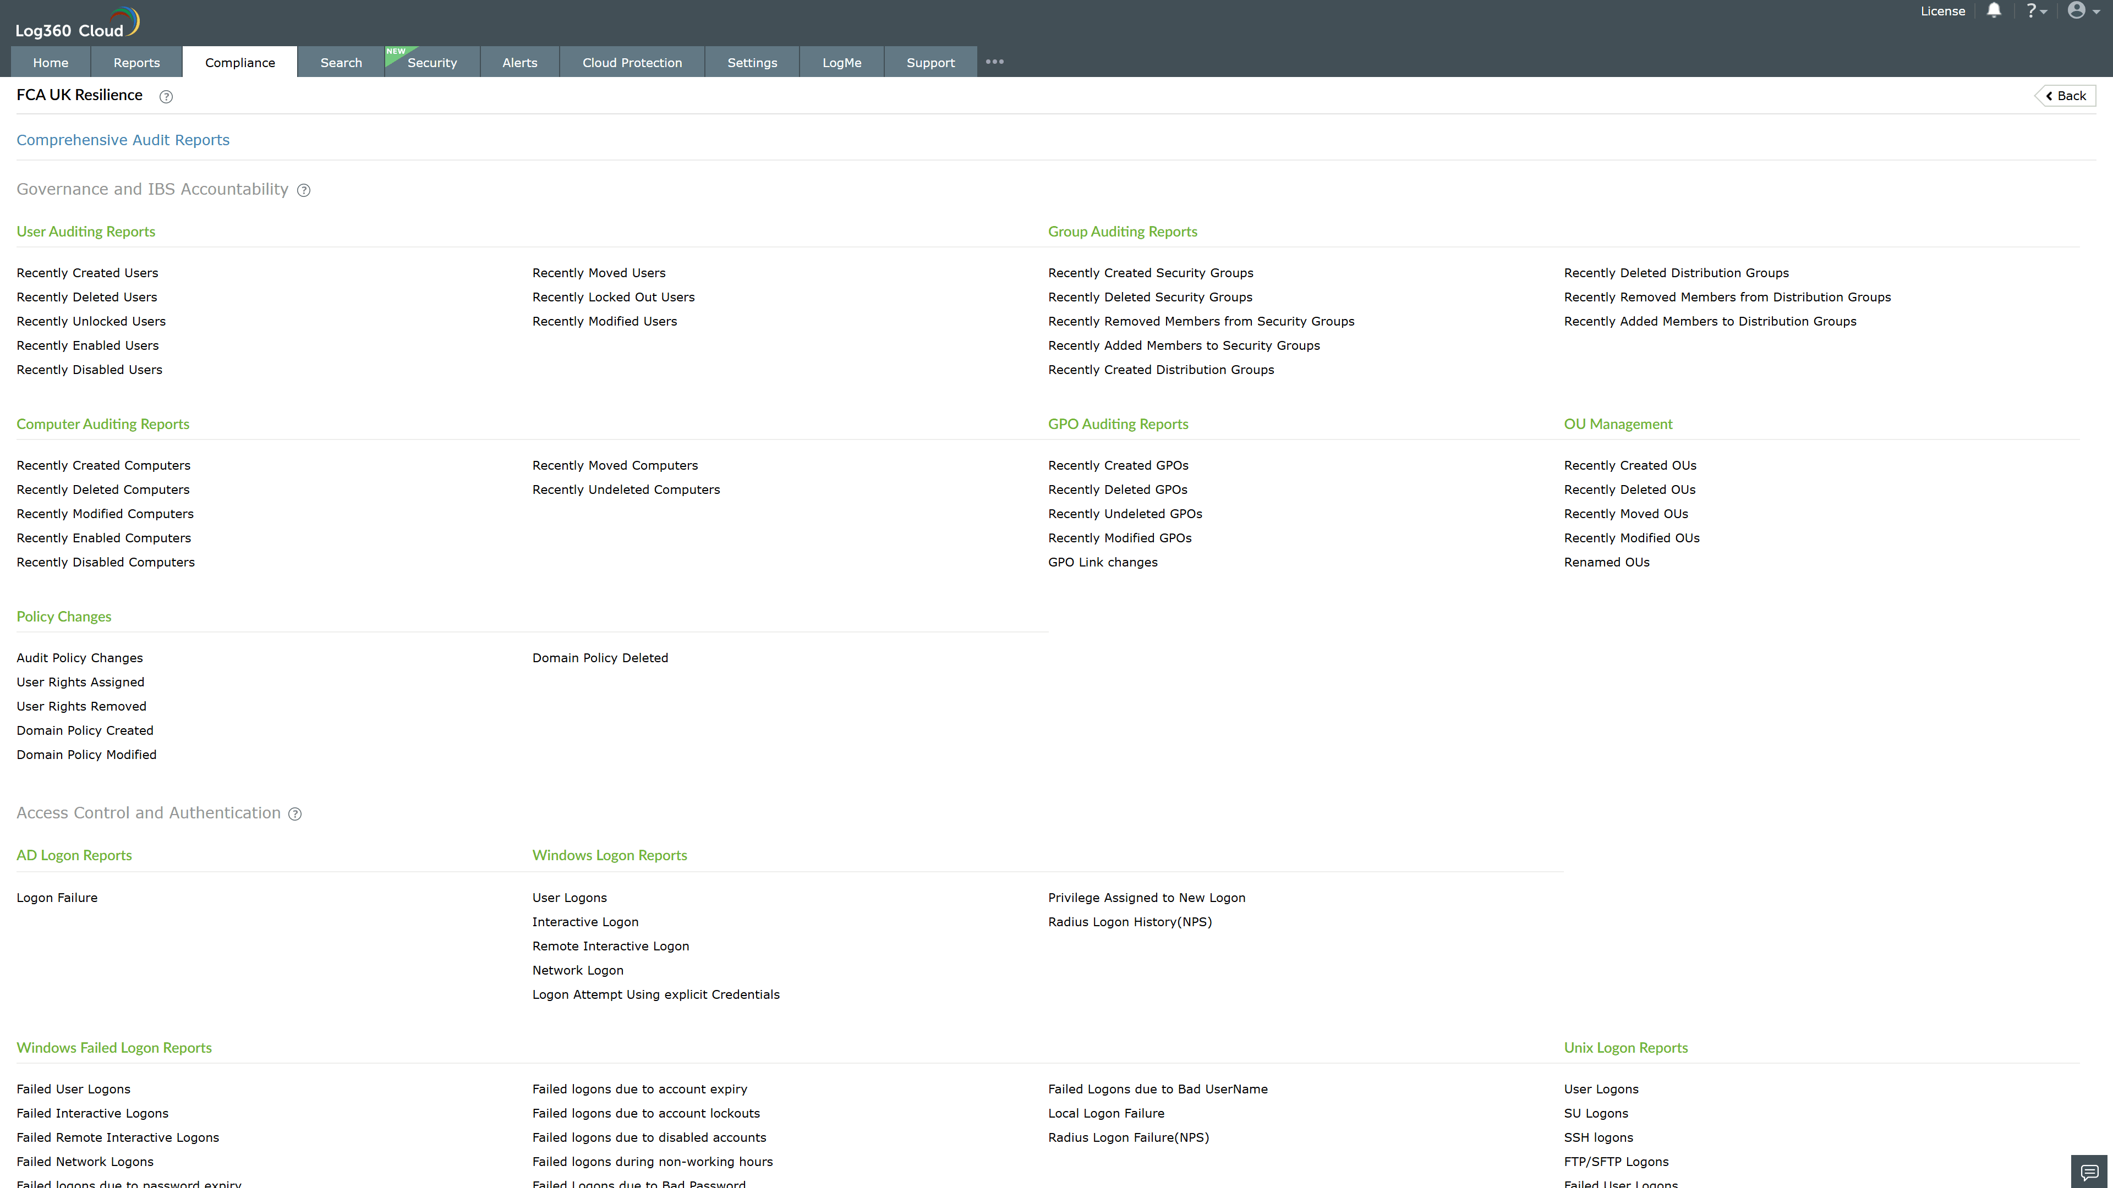
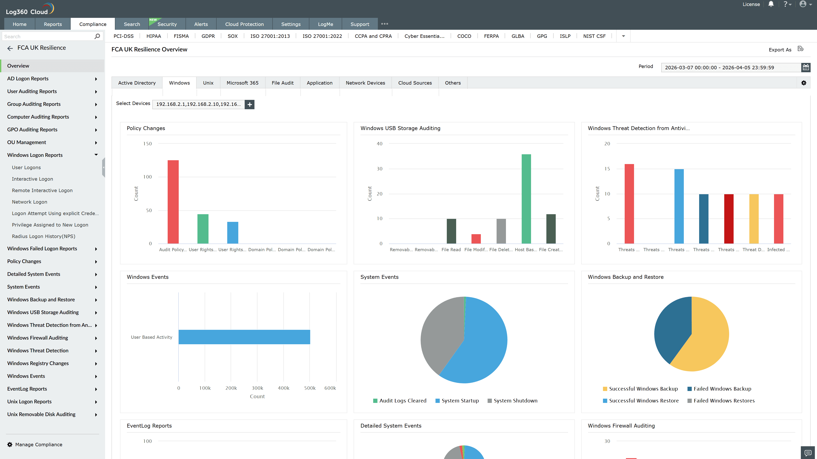
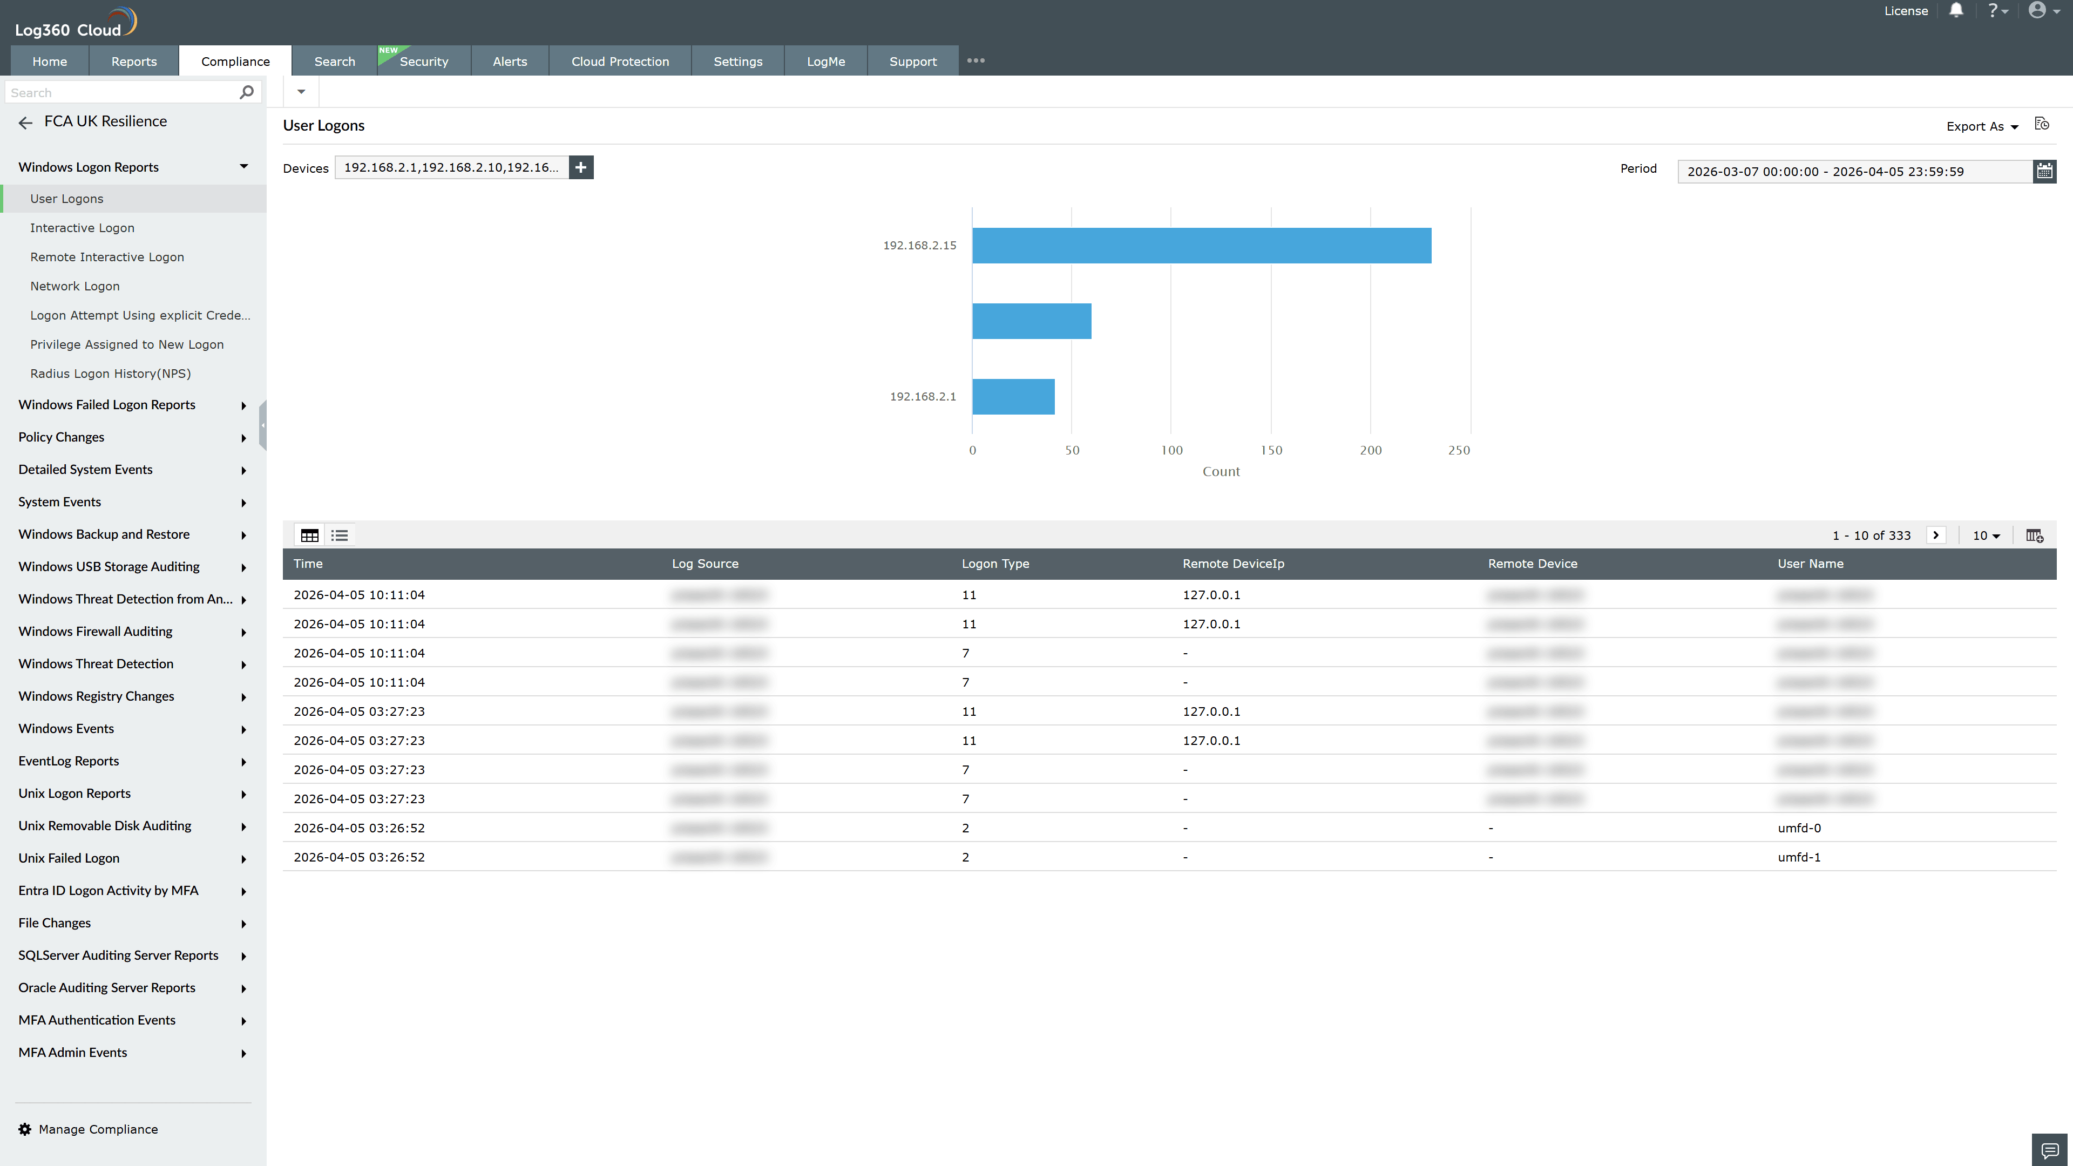
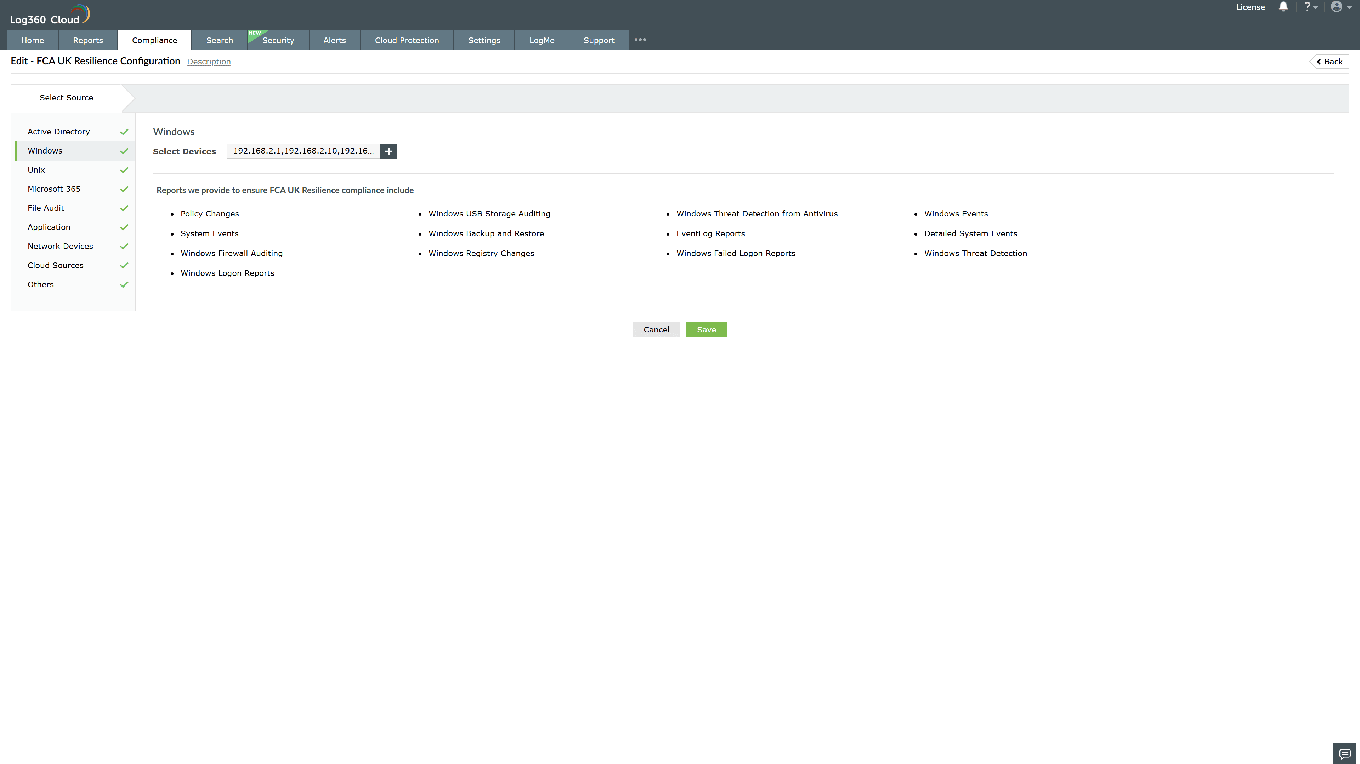
Valid Submission : Yes
Supported Editions : Free, Basic, Standard, Professional, MSSP
Help Document : https://www.manageengine.com/log-management/help/integrations/compliance-extensions.html
Help Video : Not provided
Tags : Log360, Compliance, Privacy monitoring, Data privacy, Regulatory compliance
Supported DCs : US, IN, JP, CA, AU, UK and EU
Privacy Policy:
Terms of Service:
Release Notes:
Predefined reports for the FCA UK Resilience.

